**User Guide for NeXTA-GIS:**

**Two-way SHAPE file to CSV file conversion**

First, please download the NEXTA-GIS tool package, NEXTA_GIS.zip at

<https://github.com/xzhou99/NeXTA-GMNS/tree/master/tools/GIS_shape_file_CSV_file_conversion>

Second, please unzip the package to find 1) NEXTA-GIS.exe executable and 2) three sets of sample GIS files. Note that, there are a large number of DLL files in the same folder, which are required as part of GIS SHAPE file reading utility.

<https://en.wikipedia.org/wiki/QGIS>

<https://en.wikipedia.org/wiki/Shapefile>

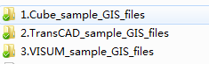

Please also go to the GMNS website to understand the WKT format used in coding node and link geometry fields.

<https://github.com/zephyr-data-specs/GMNS>

[try](https://en.wikipedia.org/wiki/Well-known_text_representation_of_geometry)

Well-known text (WKT) is a text [markup language](https://en.wikipedia.org/wiki/Markup_language" \o "Markup language) for representing [vector](https://en.wikipedia.org/wiki/Vector_graphics" \o "Vector graphics) [geometry](https://en.wikipedia.org/wiki/Geometry" \o "Geometry) objects on a [map](https://en.wikipedia.org/wiki/Map" \o "Map).

https://en.wikipedia.org/wiki/Well-known_text_representation_of_geome

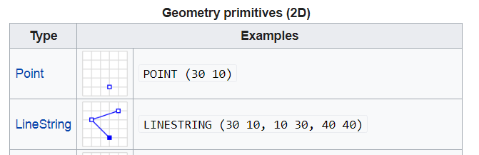

**Step 1: Ensure GIS Shape file is readable.**

Open Q-GIS, go to menu->layer->add layer-> add vector layer, and open a GIS shp file, e.g. in data folder “1.Cube_sample_GIS_files”

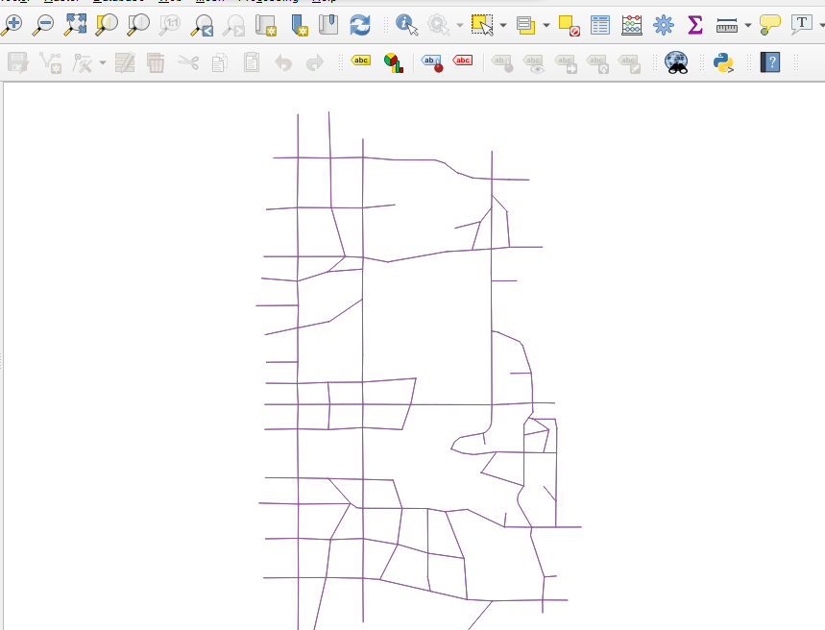

**Step 2:** Click on NEXTA-GIS.exe, Select menu Tools🡪Shapefile to CSV two-way converter,

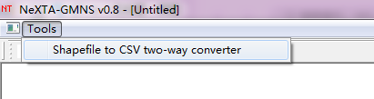

Now you can find the dialog of Import/Export Data File.

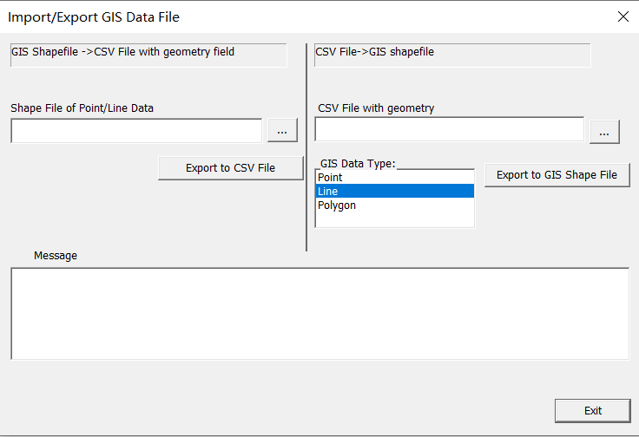

1

222222

**Step 3: Export Shaple file to CSV file**: On the left side of Import/Export Data File dialog, you can select a GIS Shape file (e.g., SLC_Network_Link.shp) and then click on the button “Export to CSV File” to save the shape file data into a new CSV file (e.g. road_link.csv).

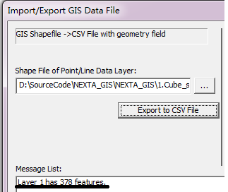

As shown above, the sample file has 378 links. The user can check the saved/converted csv file road link in Excel, where the true shape coordinate information has been stored in the required field for representing geometry in GMNS.

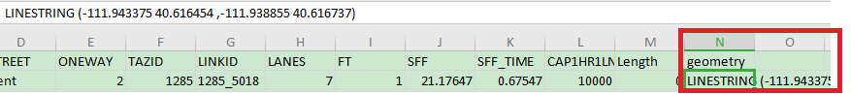

One can also use the similar step to convert a node shape file to node.csv.

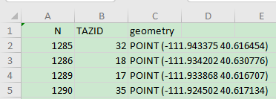

**Step 4:** One can carefully change the field name for required fields in GMNS, such as from_node_id or to_node_id in Excel. Note that, the node.csv file requires x_coord and y_coord fields, which can be converted from the field of geometry, manually using the “text to column” feature in Excel.

**Step 5: Convert two-way links to one-way links.**

In a common shape file for the link layer, a link can be coded as a two-way link. Note that, GMNS requires one-way directional links.

1. One can first add a field of “direction” with a value of 0 in road_link.csv, then use standard NEXTA tool to open the network, and then a two-way link will be automatically split to two one-way links in the interface, but without offset (so that two links are displayed as overlapping links).
2. Then continuously click on the NEXTA toolbar highlighted in yellow below, increase and decrease link offset to make two related being displayed separately.
3. The user can further save the project through menu file->save project, then the saved road_link file will have one-way links with offset geometry coordinates and the filed of “direction” = 1. This “direction” field is not required in GMNS but convenient for distinguishing two-way links and one-way links.
4. In some cases, original fields such as AB_speed, or BA_speed are coded to represent different speed limits for different directions of a two-way link, the then user needs to manually transfer the information carefully.

**Step 6: CSV file to shape file**

For any CSV files with a “geometry” field following the WKT format, one can seamlessly generate a shape file based on the CSV files.

On the right side of the Import/Export Data File dialog, you can load a CSV file and choose the type (point/line/polygon) of geometry filed, then click on the button “Export to GIS Shape File” .



One can try to save the node.csv file from Lima data set

“4.Lima_GMNS_CSV_files”

to node_test.shp and visualize the node coordinate in Q-GIS.

